**LAPPS/CLARIN/WebLicht Use Cases**

Language Grid

* Japanese version using the service manager

LAPPS

* Network of NLP services federated through langrid (<https://github.com/openlangrid/langrid>) SOAP framework, called service manager
  + developed by Kyoto
  + own AAI framework, not used by LAPPS at the moment
  + galaxy users (local) -> specific one account to service manager -> no AAI to services
  + multiple service manager - can be federated
    - at the moment, galaxy decides which service manager to use
* technical doc http://wiki.lappsgrid.org/wiki

LAPPS Galaxy

* only one public frontend at the moment
* Galaxy (<https://github.com/galaxyproject/galaxy>) as frontend (one of the possible frontends)
  + developed for bio genomics community
  + developers from PENN state
* Services primarily developed by Vassar and Brandeis

Services also by

* Vassar, Brandeis, CMU, LDC

Current implementation of user authentication on lapps-galaxy

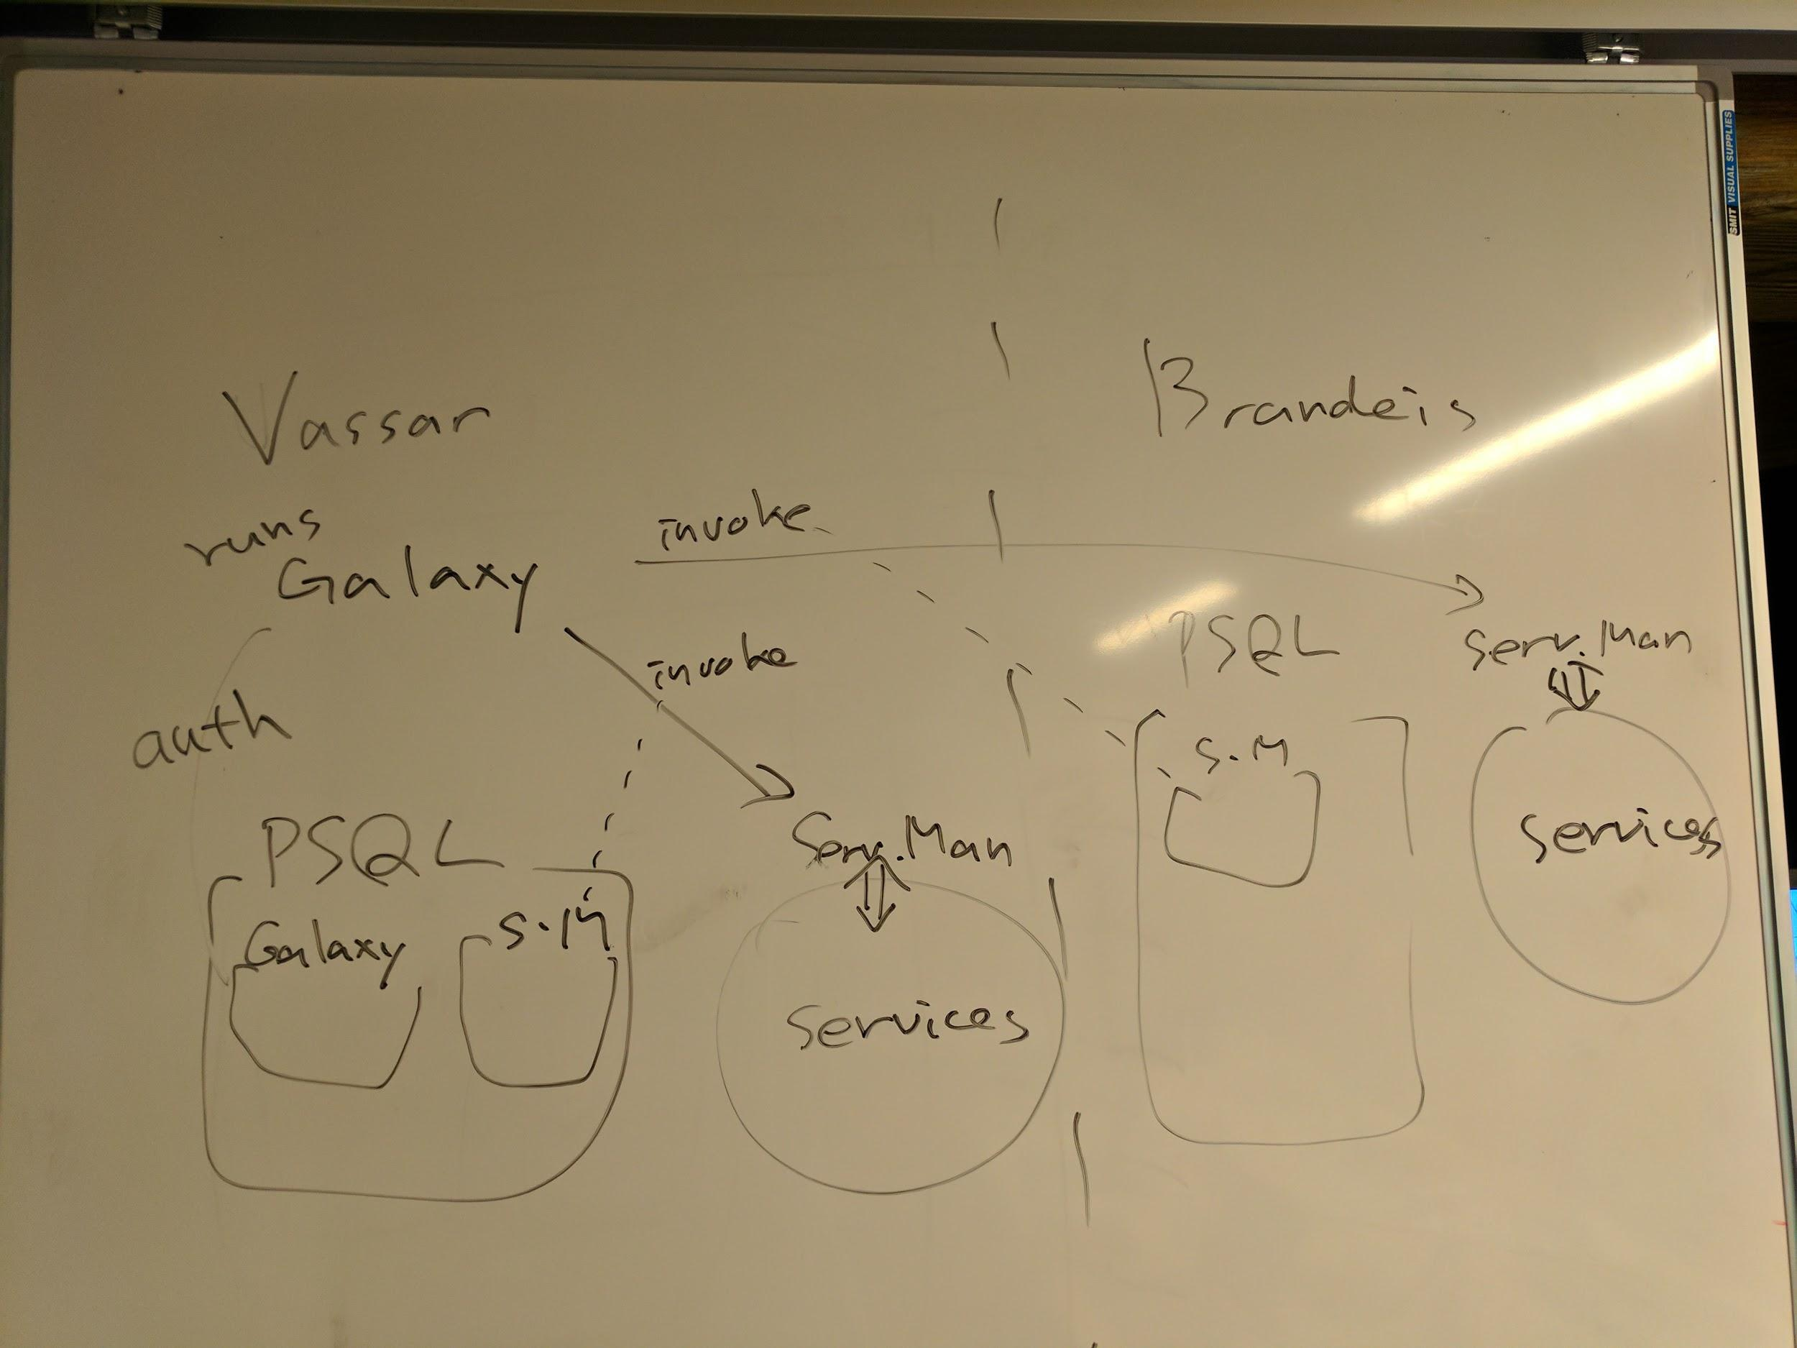

* PSQL in the picture means postgres user databases
* LDC services (gigaword) needs an additional authentication (OAuth token)

Requirements:

* Weblicht requires “academic” status/users = users via Shibboleth
* <http://weblicht.sfs.uni-tuebingen.de/weblichtwiki/index.php/FAQ>
* Galaxy users
  + any local account
  + shibboleth - very soon (CLARIN galaxy lap.clarino.uio.no)
  + in progress - 3rd party auth. <https://github.com/galaxyproject/galaxy/issues/3146>

Users:

* either LAPPS Galaxy frontend or Weblicht frontend
* academic users = authenticated via Shibboleth
  + not 100% achievable
  + can be filtered (https://lindat.mff.cuni.cz/en/how-do-i-sign-up)

Tools

* users should be able to use tools from LAPPS or Weblicht

(LINDAT/)CLARIN Tools

* exported to LAPPS via Weblicht

Shibboleth monitoring tools (contact Jozef first!!!)

* <https://lindat.mff.cuni.cz/services/aaggreg/#>
* how to integrate with your SP - <https://github.com/ufal/clarin-sp-aaggregator>

1. **User comes to Galaxy**
2. Authenticates using **local account/OAUTH2(LDC)** does not buy us any more “academic” assertion about the user
   1. you see all services from LAPPS including Weblicht
   2. cannot use Weblicht/(LDC not part of this task)
3. User tries to use **Weblicht**
   1. OPTION 1: tell user to login via Shibboleth (at LAPPS) and it will (magically) work
      1. must be implemented in Galaxy
      2. make Weblicht trust
   2. OPTION 1.1: tell user to login via Shibboleth (at Weblicht) and it will (magically) work
   3. OPTION 1.2: tell user to login via Shibboleth (at Weblicht WaaS), get api key, use the key to call WaaS application to check keys
      1. Weblicht keeps complete control
      2. calls gets counted in statistics
   4. OPTION 2: calls Weblicht services (REST API) directly - SHOULD NOT HAPPEN/WORK
      1. local users do not meet academic requirement
   5. OPTION 3: calls Weblicht services (REST API) via brandeis service manager - NO
      1. only SOAP services
   6. OPTION 4: Weblicht in their own service manager - NOT NEEDED
      1. only SOAP services
   7. OPTION 5: Redirect to Weblicht frontend, user would authenticate to Weblicht and Weblicht would have to make up an id to be used by Galaxy - TOO COMPLICATED
      1. problem - relogin
      2. would require changes in both Galaxy and Weblicht
4. **User comes to Galaxy**
5. Authenticates using **Shibboleth**
6. User tries to use **Weblicht**
   1. OPTION 1: no increase in trust - the same as local user
   2. OPTION 1.1: some services might be called directly
   3. OPTION 2: increase in trust so Weblicht blindly trusts LAPPS
   4. OPTION 3: delegation - not possible in general technically
7. **User comes to Weblicht**
8. Authenticates using Shibboleth
9. User tries to use LAPPS services (not data!)
   1. no problem - services are public

Note - data:

* not AAI problem
* Weblicht does not have it as services
* LAPPS could make data available as services
  + LDC data - cannot be used
  + other data - might be possible

Note:

Check weblicht in edugain/vassar

Note:

Token page has to double redirect as well!

Note:

Does LDC license allow to send data around? What if the service stores them? In service metadata and ToS. Information like I store information (web server logs etc.).

Restrict Weblicht services to the ones which are not “caching” - conform to LDC.

1. **User comes to Weblicht**
2. Authenticates using Shibboleth (you see all services including LAPPS)

LAPPS Grid user - local user at Galaxy

→ Get LDC document (OAuth)

User redirected to LDC: gets OAuth token

User uses token to query for document

Document is sent to Galaxy instance (user can download if they want)

→ Call Weblicht public service (Morph)

→ Call Weblicht service (requires AAI)

User directed to Weblicht browser

Check institutions, select if present, login at home institution

Data sent to Weblicht as payload (URL?), service run, result returned to Galaxy

→ call private LINDAT service (dependency)

→ Display LINDAT dependency results

CASE(2):

LAPPS Grid user - registered via Galaxy

→ Get document

Document is sent to Galaxy instance (user can download if they want)

→ Call WebLicht private service (Morph)

→ Call Weblicht service (requires AAI)

User directed to Weblicht browser

Check institutions, select if present, login at home institution

Data sent to Weblicht as payload (URL?), service run

Result returned to Galaxy

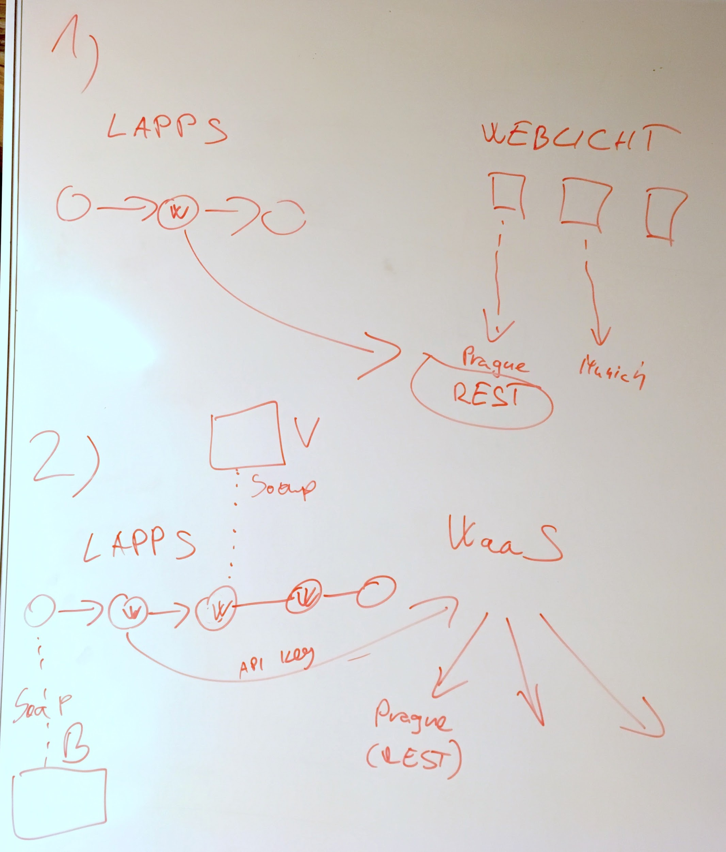

Invocation of Weblicht-integrated REST services from Galaxy: directly or via Weblicht